NEWSLETTER – January 2017

Kickstart 2017 with All-Aboard!

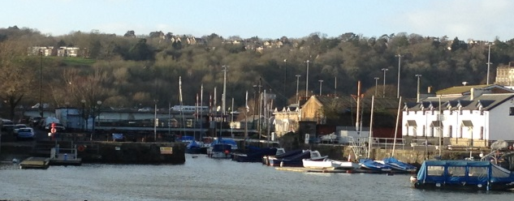
HAPPY NEW YEAR!!!

We hope that you had a brilliant time over the festive season and are ready to kick-start 2017 with a bang! We have more courses running than ever before, including advanced sailing courses (RYA Seamanship & RYA Start Racing, Multisport Taster sessions, Powerboat Courses, Sailability sessions, BCU Star one, Go Canoeing Guided Tours, Learn to Row courses, Shore-based courses and more!
Why not come and have a go! Check out our website for more information -www.allaboardwatersports.co.uk.

A fresh start for 2017 at All-Aboard!
All-Aboard! has had a busy start to the year with several SEN (Special Educational Needs) Schools and Rowing groups attending on a regular basis.
We have also started the year with a new staff member, Nicola Murdoch. We would like to welcome Nicola, our new CEO, to AllAboard! (please see below).

A note from All-Aboard’s new Chief Executive Officer – Nicola Murdoch

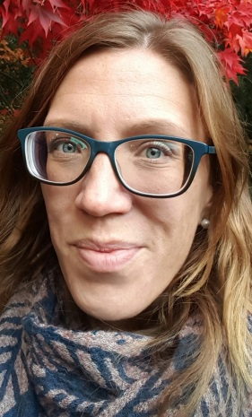
Hi everyone, I'm Nicola Murdoch, the new CEO at All-Aboard! This is an exciting new role for the charity, and one I'm really looking forward to getting stuck in to. I've worked in the charitable sector for 18 years, so bring with me plenty of experience which I will call on to guide the growth of the centre and its activities.

I've been rowing and coaching my whole life so have experienced first-hand the positive impact water sports can have on people of all ages and abilities. Making a difference is what underpins my passion for both water sports and for working in the charitable sector so this role is essentially my dream job!

I'm looking forward to meeting you all and to working alongside you.
Training and Personal Development for Instructors
& Volunteers

RYA Continuous Personal Development Days for Instructors

Maintain & develop your skills by coming to the RYA’s ‘Coach & Trainer South West Continuous Personal Development Days’. Each of these training days will target various aspects of watersport instructing, including how to improve delivery of powerboat, sailing courses, multihull and racing sessions, Instructional Techniques and more. See our Instructor Noticeboard for more information on the topics covered.

All-Aboard! will be hosting one of these sessions on Saturday 11th March. Please let the Hannah Trent or the office know if you would like to attend one of these days.

New Year Refrshers and Training
By Gill Hannan
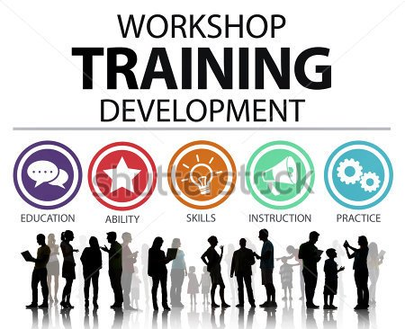
Starting in February every year we put on some extra training for our staff and volunteers to develop and maintain their skills.
A programme of all training has been sent out, but in case you have not received it, please call into the office to collect your copy and book into sessions you would like.
Some of the training is mandatory for all staff but some sessions are to give you experience in the different crafts we have available, such as the Drascombe, the Jenneau, Kyle, the displacement boat and the Katacanus. Please do take advantage of these sessions as they will allow you to build confidence in new areas.
One of the new sessions which we are putting on this year are Communication Workshops. Communication plays a crucial part in our watersport sessions, ensuring students remain safe, understand instructions and develop skills. Blaire Hannan will be delivering communication training and introducing visual timetables, and accessible information & communication aids.
These communication training sessions are important for everyone to attend. These sessions will look at different conditions amongst our client base, how & why it affects them and provide communication tips for volutneers & instructors. This is different to the Disability Awareness Course. Communication aids, visual timetables and acessible infomation will also be explained.
All of the above sessions are complementary and do not take any of your loyalty points.
We look forward to welcoming you to them.
IMPORTANT SECURITY NOTICE

With the new year we are introducing some new procedures. To improve security in our centre, we will be changing the padlock codes at the beginning of every month. Instructors will be informed of the code change, though volunteers will need to ask at the office. This will be effective immediately.

We hope this will encourage all centre users to remain mindful of security by using the lockers, shutting the centre doors and locking the boa yard gate when going on the water.
Thank-you for your co-operation.

Before All-Aboard! – Part III
By Pete Farmer
In 1868 the building now the Cottage Inn was constructed as offices for one of the timber importers. After the Docks closed in 1975 it was used as the Harbour Master’s Office before he relocated to the Underfall Yard. In 1983 it was converted into the Cottage Inn. Butcombe acquired it in 2009.
The timber yards continued to prosper beyond the end of WW2. Eventually, kiln-drying took over from seasoning, cargo ships grew too large to negotiate Horseshoe Bend and Howard’s Entrance Lock, and other Ports such as Avonmouth, Portishead and Royal Portbury could offer better facilities with cranes, secure storage and rail links. The Bristol timber (and much other) importing business fell into decline. In 1975 the Council decided enough was enough, and the City Docks closed to commercial shipping.
Then started decades of debacle over the future of the docks estate, out of which, somehow, one timber shed survived, and WESSA was born.
The rest, as they say, is history …

All-Aboard’s Mini Rowing Regatta – Sunday 22/1/17
By Jerry Boaden
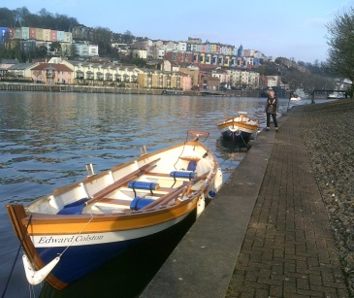
Our Pay & Play rowers and a few volunteers signed up, and promptly set everything up: Both skiffs, gazebo, table, chairs, lots of cakes and biscuits (thanks everyone!) and even some music! Teams were drawn, and bang on time, the racing start.
The weather couldn't have been much better for a mid-January afternoon, the sun even made an appearance, which made for a great afternoon's racing. Able to use both skiffs helped with speedy changeovers for the 5 crews that raced, boats coming and going almost faster than the time keepers could keep up with, so after 2 rounds of racing a time-out was called for everyone to catch their breath, and examine the first half results and plan how to improve for the next half - and eat lots of cake, biscuits, pasties etc.
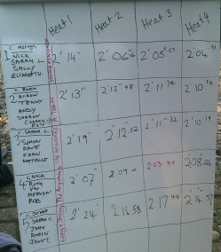
Racing was getting quite serious now for the second half as all of our 'social' rowers showed their competitive sides. With only the occasional Ferry to worry about, the racing passed off remarkably smoothly and everyone entered into the spirit for which it was intended. I'd like to thank all those who helped set up and pack away. Everybody's help made it all a very slick operation.
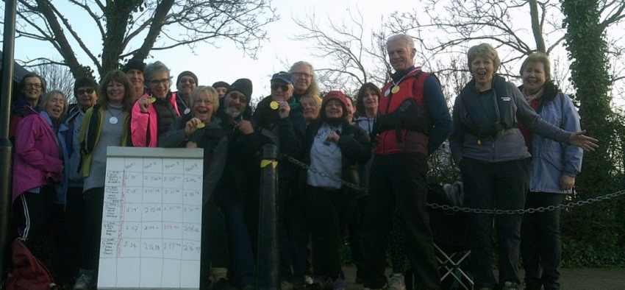
Congratulations then to the winners: Gold (I use the term lightly?) medals for the 'Argonauts' closely pushed by the 'Young Fun Ones', with the 'Winners' just squeezing the 'A Team' out by just hundredths of a second in the second session for the Bronze medals, but most important, well done everybody for taking part, 'Long and Strong' particularly, improving the most throughout the afternoon.
Let’s hope we can get more of our new starters involved for the next regatta? 6 crews? Date to be confirmed. Watch this space!

All-Aboard’s Community -

Tony Lynch cycles 802 miles!

As part of the Barclays charitable project, Tony Lynch aimed to cycle 800 miles in 2 months but in fact achieved 802 miles in 23 days!
The money raised will enable Monica Roberts (a young girl who has attended Allaboard with a ‘Young Black Carers’), to go on a 5 day voyage from Bristol to Jersey in the world’s only accessible tall ship, Lord Nelson, and enjoy the challenge of life as part of the crew.
If you would like to sponsor Tony visit http://uk.virginmoneygiving.com/TonyLynchCycles
DON’T MISS OUT! SESSIONS TO TRY

Learn to Row Open Session, Tuesdays, 6-8pm, £12
Have done a Learn to Row course or have prior rowing experience? Want to use your skills and row regularly with others of a similar skill? Then why not come to our ‘Open Learn to Row session, on Tuesdays at 6-8pm, starting 7th February.

This session is designed to give those who have previous experience of rowing the opportunity to practice and develop their skills. The session will be run by a qualified instructor and will aim to help improve fitness as well as develop skills. The session will be able to be tailored to the needs of those in the boat and the instructor will cover topics requested by participants whenever possible. You can come to as many or few sessions as you wish though we ask you to book through the office for upcoming week (Tel: 0117 929 0801)

Bristol Ageing Better (BAB)
By Anna Curvan

Do you know someone who feels a bit isolated or lonely?

If so, All-Aboard are providing opportunities for a small group of individuals to try something new and exciting. Activities are flexible depending on the individual and what they would like to do. Currently, BAB sessions take place on a Thursday afternoon but other sessions can be arranged if necessary. If you know anyone who you think would like to be involved, please have a chat with either Hannah Trent or Anna Curvan for more information.

UPCOMING EVENTS

Communication Training for Instructors, 7th Feb, 3-4pm
Communication Training for Volunteers, 21st Feb, 2.30-3.30pm

This training will look at different conditions amongst our client base, how & why it affects them and provide communication tips for volunteers & instructors. Communication aids, visual timetables and acessible infomation will also be explained. Please let the offce know if you are attending.

Optional Boat Training for Instructors & Volunteers

Induction to Access Boats, 4th Feb, 10am-12pm – Steve Evans

Induction to Kata Kanus, 11th Feb, 10am-12pm

Aiming High Familiarisation, 14th Feb, 1-3pm – Hannah Trent

Induction to Drascombe & ‘Kyle’ , 18th Feb, 10am-12pm – Steve Evans

Review & Planning Session, 24th Friday, 3-6pm

Nicola is organising a Review & Planning session for Trustees, staff and volunteers. The idea is to review what we do well, identify what we could do better, have a discussion about where we are headed as an organisation and to discuss new ideas and opportunities.

The plan is to have a bit of a social afterwards, so if you’d like to attend the session or the social (or ideally both!) please contact Blaire or Gill.

Vacancies

We will soon be advertising for the following positions:

Administrator (2 days per week)
Finance Office (10 hours per week)
Seasonal Instructors
Bosun

